**Hybrid Weather Forecasting**

**Vellore Institute of Science and Technology**

Submitted in partial fulfillment of the requirements for the award of Bachelor of Technology Degree in

Computer Science Engineering

By

**DEPARTMENT OF SCOPE**

# VELLORE INSTITUTE OF SCIENCE AND TECHNOLOGY

**CHENNAI – 600127, TAMILNADU**

# ACKNOWLEDGEMENT

**ABSTRACT**

Understanding the weather is crucial for daily life as it helps us anticipate conditions like rain or sunshine. Meteorologists rely on weather forecasting to predict future weather patterns by analyzing various parameters such as temperature, pressure, humidity, and wind speed. To predict weather accurately, we collect and analyze a significant amount of data, typically using 75-90% for training purposes. With advancements like Speech Recognition technology, users can now inquire about weather forecasts without needing to interact with a device manually, which can be especially beneficial for visually impaired individuals. This project integrates APIs for real-time data, allowing users to receive current weather reports by simply providing the name of their city. Additionally, the project employs data visualization and machine learning techniques such as Linear Regression and Naïve Bayesian Classification to analyze historical data, predict future temperatures, and forecast rainfall. Python, NumPy, Jupiter Notebook, Spyder, and Pandas are utilized throughout the project's three distinct phases: data collection and cleaning, feature refinement and model fitting, and model training and evaluation.

# TABLE OF CONTENTS

**Chapter**

|  |  |  |
| --- | --- | --- |
| **No.** |  | **No.** |
|  | **ABSTRACT**  **LIST OF FIGURES** | **vi ix** |
|  | **LIST OF ABBREVIATIONS AND MODULES** | **ix** |
| **1** | **INTRODUCTION**  1.1 GENERAL | 1 |
|  | 1.2 OBJECTIVE | **1** |
|  | 1.3 OVERVIEW OF THE PROJECT | 1 |
| **2.** | **AIM AND SCOPE** |  |
|  | 2.1 AIM | 2 |
|  | 2.2 PROJECT SCOPE | 2 |
|  | 2.3 PROBLEM STATEMENT | 3 |
|  | 2.4 EXISTING SYSTEM | 3 |
|  | 2.5 DISADVANTAGE OF EXISTING SYSTEM | 3 |
|  | 2.6 ADVANTAGE OF OVER CURRENT SYSTEM | 3 |
| **3** | **PROJECT DESCRIPTION**  3.1 OVERVIEW | 4 |
|  | 3.2 FEATURES OF THIS APPLICATION | 4 |
|  | 3.3 FORECAST DATA | 5 |
|  | 3.6 WEATHER PREDICTION | 6 |
|  | 3.5 TEMPERATURE PREDICTION | 6 |
|  | 3.6 ADVANTAGE AND DISADVANTAGE OF WEATHER  FORECASTING | 7 |

# TITLE Page

3,7 PRACTICAL APPLICATION OF WEATHER 7

FORECASTING

* 1. APPLICATION IN VARIOUS FIELDS 8
  2. SUMMARY 8

1. **SYSTEM ANALYSIS AND DESIGN**
   1. GENERAL 9
   2. SOFTWARE USED 9
   3. SYSTEM REQUIREMENT 10
   4. PROCESSING DATA 11
   5. FUNCTIONAL REQUIREMENT 11
   6. DATA COLLECTION 12
   7. PROJECT DESCRIPTION 12
   8. WORKFLOW DIAGRAM 13

# CONCLUSION AND FUTURE WORK

* 1. PROJECT OUTLOOK 22
  2. CONCLUSION 22
  3. FUTURE WORK 23

**REFERENCES**

**LIST OF ABBREVIATIONS AND MODULES**

Python - Using Source Language ML - Machine Learning

**MODULES -** Tkinter, request, time, matplotlib, pandas, skylearn

# CHAPTER 1 INTRODUCTION

* 1. **GENERAL**

A Weather prediction is used to predict the current weather situation. The application of physics principles, augmented by a range of statistical and analytical methods, to predict the weather is known as weather forecasting. Weather forecasting provides forecasts of shifts in the Earth's surface temperature in addition to predictions of atmospheric phenomena. These shifts are influenced by atmospheric conditions such as snow and ice cover. The foundation for weather prediction began with ancient Greek philosophers' theories and continued with Renaissance scientists. Any weather prediction requires a systematic compilation of weather records from different locations, as well as adequate data analysis and prediction.

# OBJECTIVE

The objective of this application is that it saves time, simple and efficient. It is mainly to avoid scared about weather related problems. The blind people can also handle this application.

# OVERVIEW OF THE PROJECT

We have developed the system in such a way that it can be used efficiently by all the users. Let’s Assume all the webpages and logics related to admin and users as separate modules. We have two modules and each of these modules have their own unique functions. Important thing is that it is not designed for particular type peoples. This application can help all the users to access the weather report details through internet or intranet that means anytime and anywhere. We wanted

to create a tool that fits into modern age, but still stays true to the “***concepts of studying”***. So, this process also helps in maintaining consistency and integrity. This system helps the user to generate the dynamic legwork.

# CHAPTER 2

**AIM AND SCOPE**

# AIM

The goal of weather prediction is to provide information people and organizations can use to reduce weather-related losses and enhance societal benefits, including protection of life and property, public health and safety, and support of economic prosperity and quality of life. In economic terms, the benefit of the investment in public weather forecasts and warnings is substantial: the estimated annualized benefit is about $31.5 billion, compared to the $5.1 billion cost of generation the information.

# PROJECT SCOPE

The main aim of this project is predict the weather report and should be useful for all kind of peoples. Based on this type of application we can avoid unwanted weather related problem. The Linear Regression algorithm, which is used to forecast weather using these data, is at the center of this project, the higher the precision, the more parameters considered. This project has the potential to assist a large number of people in predicting tomorrow's weather. Temperature, dew, pressure, and humidity are simply used to train the data in this project. These data are then used to train a prediction model using Linear Regression.

# PROBLEM STATEMENT

The peoples cannot know rainfall, snow etc.., and they couldn’t be able to prevent from that natural disaster. Though using this application one can easily find out their current weather situation in live location.

# EXISTING SYSTEM

The people cannot know the current weather situation. So that the people face many issues (like people going for outside purchase during the rain fall). Abstract weather problem is defined in many areas and it’s hard to solve, because it includes many constraints that should be solved. Its doesn’t have analysing process.

# DISADVANTAGE OF CURRENT SYSTEM

* + - Takes a lot of time.
    - Less Accurate.
    - Not capable to contain all the information.
    - Separate social media required.
    - High complexity and additional setting efforts.

# ADVANTAGES OVER CURRENT SYSTEM

* Easy to handle and operate.
* Friendly interface.
* Fast and convenient.
* Easy to update.
* Easy message passing.
* Smart way of communication
* Secure

# CHAPTER 3 SYSTEM IMPLEMENTATION

* 1. **OVERVIEW**

The fundamental idea behind my project is to create a website that would make greater this easier. I wanted to create a tool that fits into modern age, but still stays true to the concepts of studying. Following is the detail of different modules of my project.

# FEATURES OF THE APPLICATION

Using this application we comes to know the weather situation in live locations. This application dashboard contains speech recognition, current weather report for specific city, Analyze average rainfall for every month in India, Rainfall predict the Tomorrow, Predict the temperature for year, comparing original temperature vs predict temperature.

# Speech Recognition

The blind people can also access this project using this features.

Its option features the user can take this option once if need.

# Current weather report for specific city

Using this feature the people can know current weather report for live location and specific city. Its contains humidity, temperature, etc…, **Analyze average rainfall for every month**

Using this feature one can analyse the monthly fall rain level. Based on this we can analyse the rainfall and predict the rainfall for next year.

# Rainfall predict the tomorrow

Using this feature one can predict the rainfall will happen for tomorrow or not

# Predict the temperature for every year

Using this feature can predict the temperature for yearly and

analyse.

# Comparing original vs predict temperature

Using this features the developer can comes to know the difference between the original to predicted temperature.

# FORECASTE DATA

* + - Between 1980 and 2009 - 96 weather disasters in the United States each caused at least$1 billion in damages, with total losses exceeding $700 billion (NCDC, 2010).
    - Between 1999 and 2008 - there were an average of 629 direct weather fatalities per year (NWS, 2010).
    - The annual impacts of adverse weather on the national highway system and roads are staggering:
    - 1.5 million weather-related crashes with 7,400 deaths, more than 700,000 injuries, and $42 billion in economic losses (BTS, 2007).
    - In addition, $4.2 billion is lost each year as a result of weather-related air traffic delays (NOAA, 2010).
    - Weather is also a major factor in the complex set of interactions that determine air quality; more than 60,000 premature deaths each year are attributed to poor air quality (Schwartz and Dockery, 1992).

# WEATHER PREDICTION

Get the current weather report for a location by city name. Using this we can get the temperature for current location get to know temperature, humidity, chill, cold etc…, The OpenWeatherMap API currently provides a wide variety of weather data including current weather, forecasts, historical, weather stations and weather alerts. The API documentation is comprehensive, easy to follow and includes many examples of API requests and the responses returned.

# TEMPERATURE PREDICTION

We will work on forecasting the average global land and ocean temperature using over 100 years of historical weather data. We’ll pretend that we don’t have access the any weather forecasts. Through a comparative study of weather data collected in Central Kerala from 2007 to 2015. We propose a system for temperature prediction using three machine learning models. Multiple Linear Regression (MLR), Artificial Neural Network (ANN), and Support Vector Machine (SVM). We still have a century's worth of historical global temperature averages, including global maximum and minimum temperatures, as well as global land and ocean temperatures. Having all of this, we know that this is a supervised, regression machine learning problem. Mean Error (ME), Mean Absolute Error (MAE), and other metrics are used to assess the experimental outcomes.

# ADVANTAGE AND DISADVANTAGE OF WEATHER FORECASTING

|  |  |
| --- | --- |
| **WEATHER FORECASTING** | |
| ADVANTAGES | DISADVANTAGES |
| * Farmers can know when to plant or harvest their crops | * Weather is extremely difficult to forecast correctly |
| * People can choose where and when to take their holidays to take advantages of good weather | * It is expensive to monitor-so many variables from so many sources |
| * Surfers known when large waves are expected | * The computers needed to perform the millions of calculations necessary are expensive |
| * Regions can be evacuated if hurricanes or floods are expected | * The weather forecasters get blamed if the weather is different from the forecast |
| * Aircraft and shipping rely heavily on accurate weather forecasting | * Weather is extremely difficult to forecast correctly |

* 1. **PRACTICAL APPLICATIONS FOR WEATHER FORECASTING**
     + Systematic weather records were kept after the invention of the instruments for measuring atmospheric conditions during the 17th century. Undoubtedly, these early records were employed mainly by those engaged in agriculture.
     + Planting and harvesting can be planned better and carried out more efficiently if all the long-term weather patterns are estimated in advance.
     + Weather warnings are a special kind of short-range forecasts. It is needed for the protection of human life from weather extremes. Weather warnings are issued by government and military organizations throughout the world for all kinds of threatening weather events like tropical storms which are called as hurricanes, typhoons, or tropical cyclones, depending on location.

# APPLICATIONS IN VARIOUS FIELDS

There are a number of sectors with their own specific needs for weather forecasts and specialist services are provided to these users.

# AIR TRAFFIC:

* Accurate weather forecasting is critical in the aviation industry because it is so weather-sensitive. Many planes are unable to land or take off due to fog or very low ceilings. Turbulence and freezing are two other major in-flight dangers.
* Thunderstorms cause extreme turbulence due to updrafts and outflow boundaries, icing, and are a concern for all aircraft. Volcanic ash is also a significant issue for aviation, as ash clouds can cause aircraft to lose engine power.
* Airliners are diverted on a daily basis to take advantage of the jet stream tailwind to increase fuel quality. Prior to take off, aircrews are briefed on what to expect en route and at their destination. Furthermore, airports often alter which runway is in use.

# MARINE

* Wind direction and intensity, wave periodicity and heights, tides, and precipitation can all restrict commercial and recreational use of waterways. Any of these factors may have an effect on the safety of marine transportation.
* As a result, a number of codes have been developed to effectively transmit comprehensive marine weather forecasts to vessel pilots via radio, such as the MAFOR (marine forecast) code.
* RTTY, Navtex, and Radiofax can all be used to receive standard weather forecasts at sea.

# AGRICULTURE

* + Farmers use weather forecasts to determine what work they can do on any given day. Drying hay, for example, is only possible in dry weather. Dry spells will wreak havoc on cotton, wheat, and corn crops.
  + Drought can destroy corn crops, but their dried remains, known as silage, can be used as a cattle feed substitute. Both in the spring and

the fall, frosts and freezes wreak havoc on crops. A spring freeze, for example, will decimate the future peach crop of peach trees in full bloom. Orange groves can be severely harmed by frosts and freezes, regardless of when they occur.

# FORESTRY

* Wind, precipitation, and humidity forecasting are critical for preventing and managing wildfires.Various indices have been created, such as the Forest fire weather index and the Haines Index, to predict which areas are more likely to experience fire due to natural or human causes.

# UTILITY COMPANIES

* + Rain forecasts are used by electricity and gas firms to predict demand, which is heavily influenced by the weather. They calculate the degree day to see how much heating (heating degree day) or cooling (cooling degree day) can be used (cooling degree day).
  + These figures are based on a daily average temperature of 65 degrees Fahrenheit (18 degrees Celsius).Heating degree days (one per degree Fahrenheit) are triggered by cooler temperatures, whereas cooling degree days are triggered by warmer temperatures.
  + In the winter, when people turn up their heating, extreme cold weather can cause a surge in demand. Similarly, increased use of air conditioning systems in hot weather will lead to a rise in demand in the summer. By foreseeing a spike in demand.

# SUMMARY

The prediction method is in good working order. Many of the attribute values had been correctly preprocessed. So all kinds of can use this application and get to know the weather report easily without knowing the technical knowledge. This application is very useful for professionals to analyse the temperature and rainfall for monthly or yearly level. Blind people can handle this efficiently using speech recognition.

# CHAPTER 4

**SYSTEM ANALYSIS AND DESIGN**

# GENERAL

* + 1. **PYTHON**

Python is a widely used open-source Object oriented language that is especially suited for Machine Learning.

# USER INTERFACE (UI)

The user interface (UI) is the point of human-computer interaction and communication in a device. This can include display screens, keyboards, a mouse and the appearance of a desktop. It is also the way through which a user interacts with an application or a website

# SOFTWARE USED

* + 1. **CODE EDITOR USED Python IDLE**

IDLE is an integrated development environment for Python, which has been bundled with the default implementation of the language since 1.5.2b1. It is packaged as an optional part of the Python packaging with many Linux distributions.

* + 1. **ALGORITHMS USED Linear Algorithm**

Regression is a method of modeling a target value based on independent prediction. This method is mostly used for forecasting and finding out cause and effect relationship between variables. Regression techniques mostly differ based on the member of independent variables and the type of relationship between the independent and dependent variable.

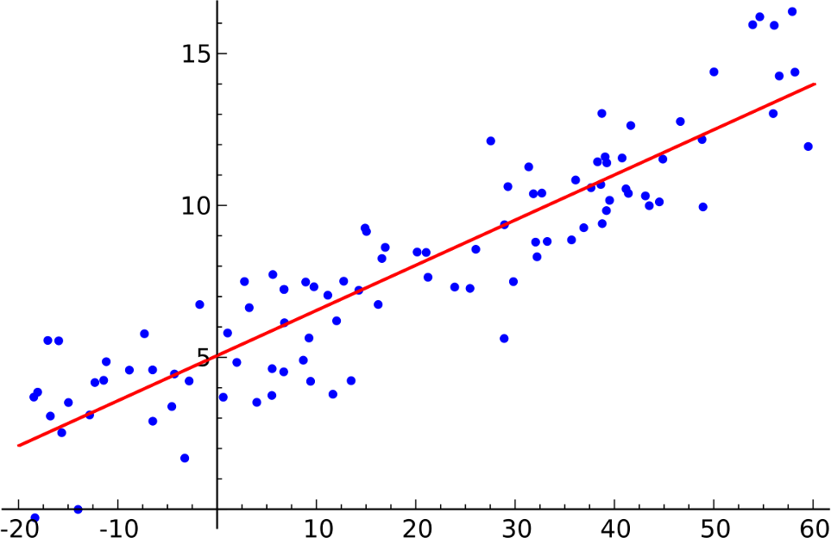

**Naïve Bayes Classification**

Naïve bayes algorithm is a probability machine learning algorithm which can be widely used in various classification tasks which is based on Bays theorem. The term naïve is given because is assumes the data that is given so the model are independent of each other, that is they have independent distribution. So, if we change the value of one feature than it doesn’t affect the value of other features used in the algorithm.

# SYSTEM REQUIREMENT

* Operating System: Windows/Mac
* RAM: 4GB
* Processor: 64x 1.0Ghz processor
* ROM: 8GB

# PREPROCESSING DATA

The steps involved in pre-processing are

# Features selection

The data we have collected has many unwanted attributes which will not be needed in our project. Hence, we use the attributes which we need only.

# Normalization

The data we collected from internet should be first normalized. Normalization refers to rescaling real valued numeric attributes into the rage or 0 and 1. After the data are filtered it is then normalized.

# Machine Learning

Training a model is the process of iteratively improving your prediction equation by looping through the dataset multiple times, each time updating the weight and bias values in the direction indicated by the slope of the cost function (gradient). Training is complete when we reach an acceptable error threshold, or when subsequent training irritations fail to reduce irritations.

# FUNCTIONAL REQUIREMENTS

* + - The system must provide the predicted weather.
    - The system must have an easy to use interface for using the system for all the users.
    - The Admin must be able to update/modify the Dataset.
    - The Dataset of the weather must be available for the system.

# DATA COLLECTION

The data of weather forecast was obtained from Kaggle. We took about 4000 trained data and 800 test data.

# Parameters are:

* Temperature
* Pressure
* Humidity
* Dew point
* Rainfall
* Precipitation

# 4.4 PROJECT DESCRIPTION

The project aim is to show the weather report for everyone. This project used to show the report for all attributes and user can easily know about the weather forecast, chillness, sunset, sunrise etc…, According to that the user comes to know weather problems. Here speech recognition also included for extra one feature. Despite of the blind people also able to work with it. Using the API included all kinds of weather attributes. From the data collection, we know the weather report either current or specific city which is defined by users. The Government can analyze every year or every month wise rainfall level in order to that we can predict rainfall for future year or month. Based on comparing the original versus predicted temperature the developers can find the difference of the temperature.

# WORKFLOW DIAGRAM

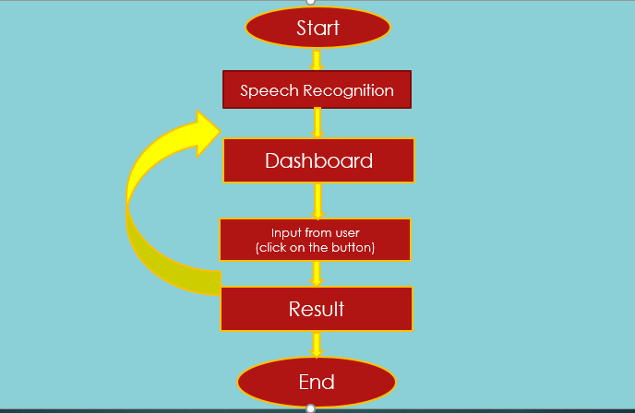

* 1. **FIGURE**

# DATA FLOW DIAGRAM

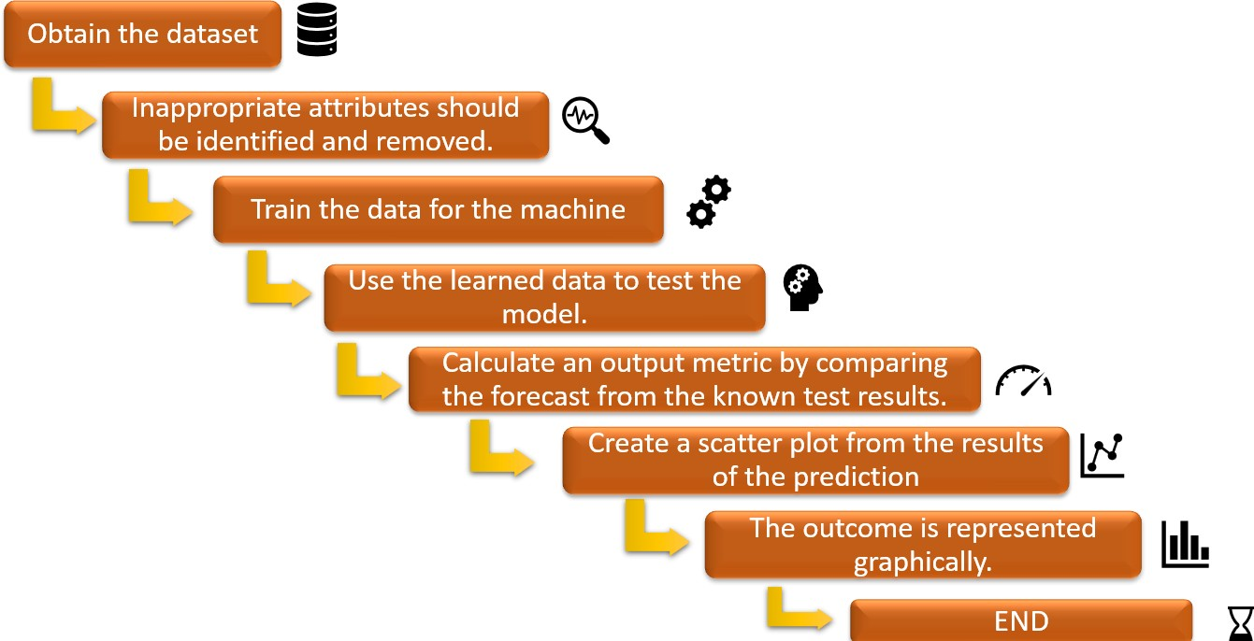

* 1. **FIGURE**

# FLOW DIAGRAM FOR SPEECH RECOGNITION

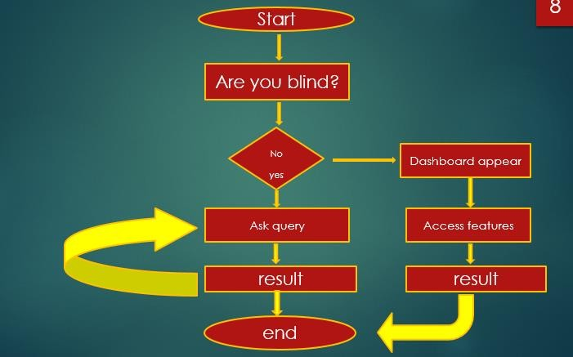

* 1. **FIGURE**
     1. **ALGORITHM FOR WEATHER REPORT STEP 1:** Import libraries

**STEP 2:** Using API can predict the weather report for current specific city once enter the city name.

**STEP 3:** API URL:

"https://api.openweathermap.org/data/2.5/weather?q="+city+"&appid=06c921750b 9a82d8f5d1294e1586276f“

**STEP 4:** Using the Json to get data

**STEP 5:** Display the output

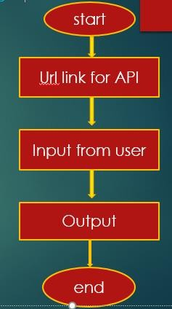

# FIGURE

* + 1. **ALOGRITHM FOR LINEAR REGRESSION ( Temperature prediction) STEP 1:** Load the dataset into the python and import the libraries

**STEP 2:** Data pre-processing

**Step 2.1:** Drop the unnecessary column from the dataset

**Step 2.2:** Delete all values from te pressure which has a value -9999

**Step 2.3:** Taking all the features into x variable and y for prediction

**Step 2.4:** Set the dummies value as a level for the weather classification

**Step 2.5:** Delete last dummies value which is null

**Step 2.6:** Concatenate the dummies value with the input feature X

**Step 2.7:** Created the new dataset after apply the preprocess

**STEP 3:** Train and test the data

**Step 3.1:** Splitting Dataset into train set and test set

**STEP 4:** Fitting the Linear Regression model

**STEP 5:** Histogram of data (visualization)

**STEP 6:** Analyze the original with predicted data (using visualize)

**STEP 7:** Output

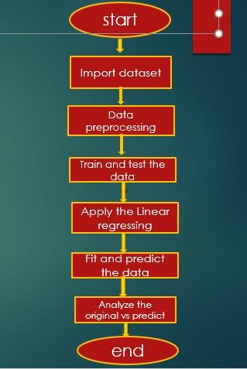

# FIGRUE

* + 1. **ALGORITHM FOR RAINFALL PREDICTION STEP 1:** Load the data and import libraries

**STEP 2:**Replace the value for ‘RainToday’ and ‘RainTomorrow’ columns with (No:0, yes:1)

**STEP 3:** Visualize the data

**STEP 4:** Output

**CHAPTER 5 CONCLUSION AND FUTUTE WORK**

# PROJECT OUTLOOK

A weather prediction goal is show the weather report for everyone. This project used to show the report for all attributes and user can easily know about the weather forecast, chillness, sunset, sunrise etc…, According to that the user comes to know weather problems. Here speech recognition also included for extra one feature. Despite of the blind people also able to work with it. Using the API included all kinds of weather attributes.

# CONCLUSION

Weather forecasting using the linear regression algorithm and the Naïve Bayes algorithm is critical for improving people’s future results. The linear regression algorithm and the Naïve Bayes algorithm were used to forecast the weather using weather datasets. Using some selected input variables obtained from kaggle, GitHub we created a model to predict the weather. The issue with the current weather situation is that we are unable to organize ourselves and complete essential tasks. As a result, this model was developed in order to know the weather scenario with high precision while taking into account all of the factors that influence the weather scenario.

# FUTURE WORK

A weather prediction technology can stipulate university growth and development. The scope magnitude of change that are occurring in department today are both exciting and daunting, very particularly we are contemplating how we will manage the many streams of technological innovations pouring into our department and networked information world. All the social medias combine to create one. This application should need to know to avoid natural disaster. To overcome that problem we have improve this to advanced features included. And then using speech recognition we need to pronounce correctly or else it will not work correctly. So that need to improve without this critical.

# REFERENCES